**STUDENT ID: 4201098**

**NAME: NGUYEN THAI SON**

**FLOWCHART**

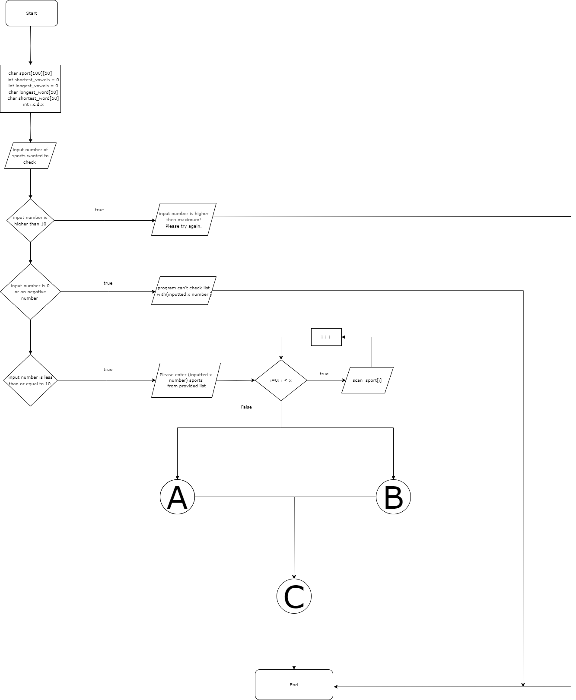

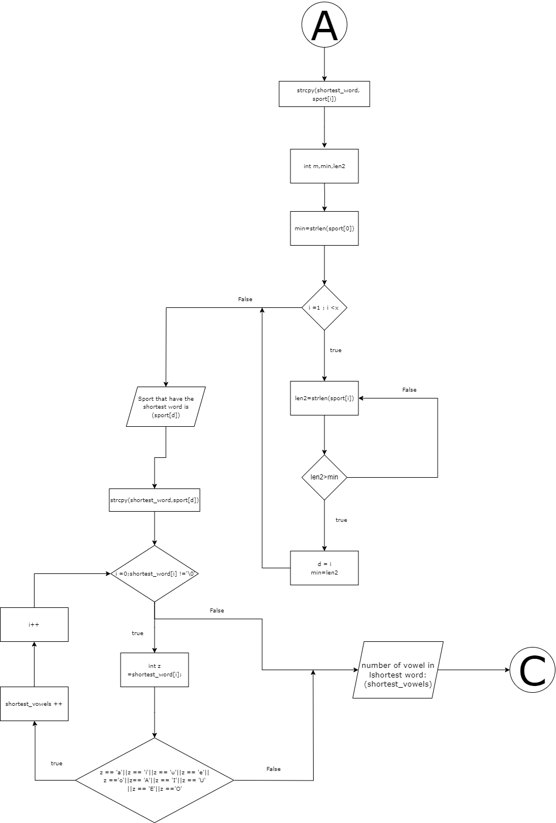

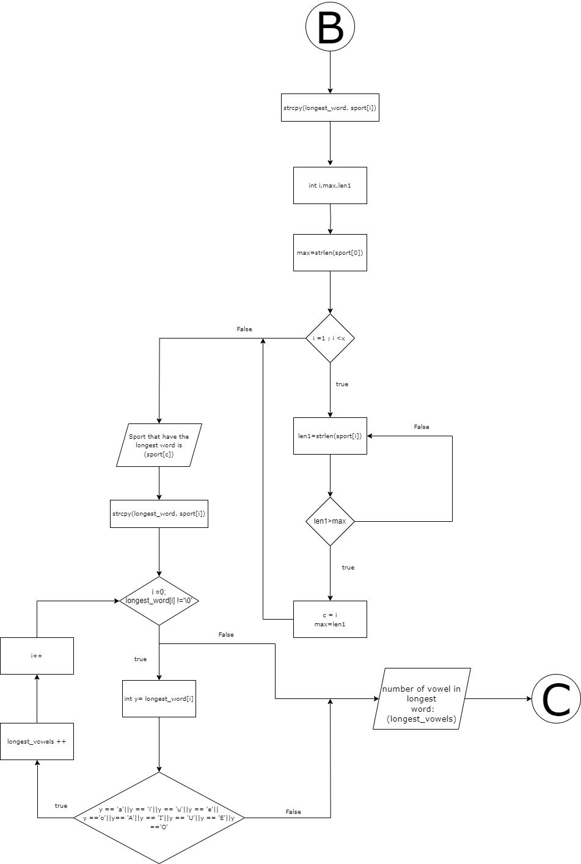

**PSUEDOCODE**

START

Declare sport as character array that hold 100 word each containing 50 character max

Declare x,I,c,d as a integer

Declare shortest_vowels as a integer =0

Declare longest_vowels as a integer =0

Declare longest_word as a character array that hold 50 character max

Declare shortest_word as a character array that hold 50 character max

Prompt user to input a password

Print How many sports do you want to check (max 10 word):

Input x

If x bigger than 10

{

Then print: ------------------------------

input number is higher than maximum!

Please try again

End if

}

else if x smaller or equal to 0

{

then print: ------------------------------

program can't check list with (x)

End Else If

}

Else {

Then print: ------------------------------

Please enter %d sports from this list: Basketball, Volleyball, Gymnastics, Swimming, Badminton, Archery, Beach-volleyball, Boxing, Cycling, Diving, Equestrian, Fencing,Football, Golf, Handball, Hockey, Bowling, Judo, Karate, Tennis, Weightlifting:

------------------------------

For I from 0 to the length of x - 1

{

INPUT sport[i]

End for

}

{

Declare i,max,len1 as integers

max=length(sport[0])

For i from 1 to the length of x -1

{

len1=length(sport[i])

If len1 bigger than max

{

Then c=i

max=len1

End If

}

End For

}

Printf Sport that have the longest word is (sport[c])

}

longest_word = sport[c]

For I from 0 to length(longest_word) -1

{

Declare y as longest_word[i]

If (longest_word[i]) have vowels

{

Then longest_vowels += 1

End If

}

End For

}

Print number of vowel in longest word (longest_vowels)

{

Declare m,min,len2 as integers

Min = length(sport[0])

for I from to x -1

{

len2 = length(sport[i])

if len2 smaller than min

{

Then d = i

Min = len2

End If

}

End For

}

Print Sport that have the shortest word is: (sport[d])

shortest_word = (sport[d])

For i from 0 to (shortest_word[i]) -1

{

Declare z as (shortest_word[i])

If z has vowels

{

Then shortest_vowels += 1

End If

}

End For

}

}

Print number of vowel in shortest word: (shortest_vowels)

End Else

}

return 0

**CODE EXPLAINATION**

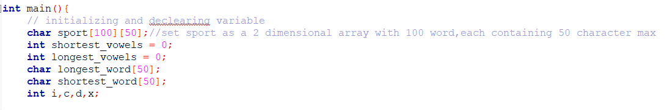

* I start off by naming and declaring the necessary variables and arrays for the code. Sport is set as a 2-dimensional character array with a 100-word limit, each containing 50 characters. Shortest vowels and longest vowels are set as integers in the vowel count holder for the longest and weakest words.

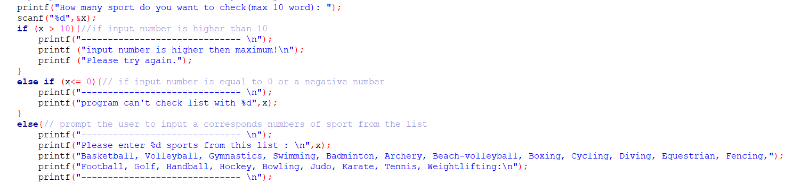

* Next, I create a print sentence to prompt the user to enter a number of sports that they want to check, with a limit of 10 words max.
* If the input number is higher than 10, it will print a warning for the user to know that the number isn’t suitable for the code.

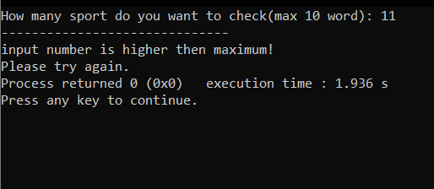

* Same output would happen if user input 0 or a negative number

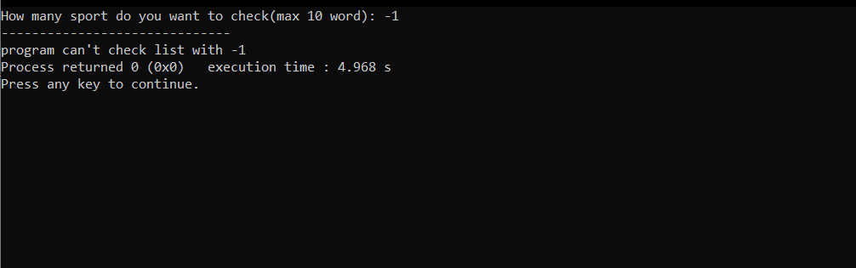

* If the user input a number smaller or equal to then 10 then the code would print out the list of sports to check from along with the inputted value.

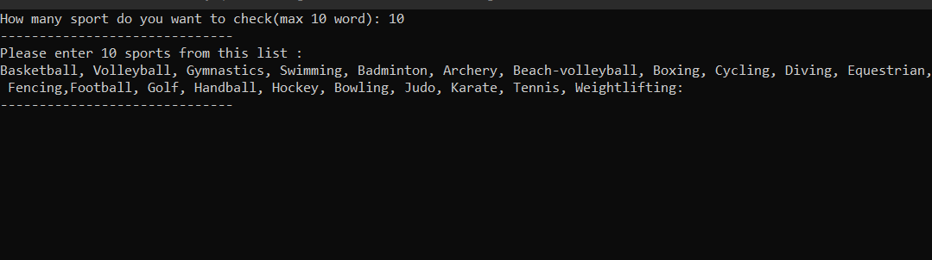

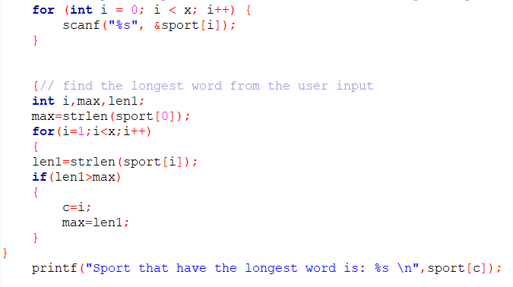

* In this step, when the user input a list of sports ( springs ) the for loop will provide stabilities which help avoid crash when input list have comma,space and new line between them.
* The new integers i, max, and len1 are declared to find the longest word in the inputted list of sports. Max is equal to strings sport[0] length, while len1 is equal to strings sport[i] length.

* This means that if len1 is higher than max, then the c array is equal to I, and max = len1, which is the highest word in the string. The code will print out the highest word from the sport[c] array. 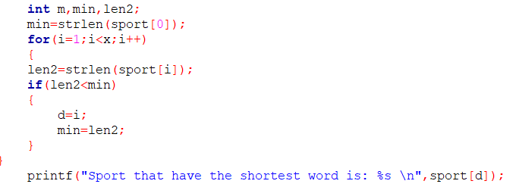
* To find the amount of vowels in the highest word we need to copy the word from sport[c] array to the character longest_word array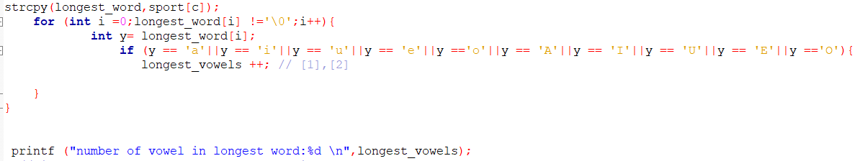
* We would then use the for loop to check to see if there are any vowels found in the longest_word array. It will increase longest_vowels by 1 each time it finds a vowel, which the print function will use to print out the number of vowels founded in the largest word.

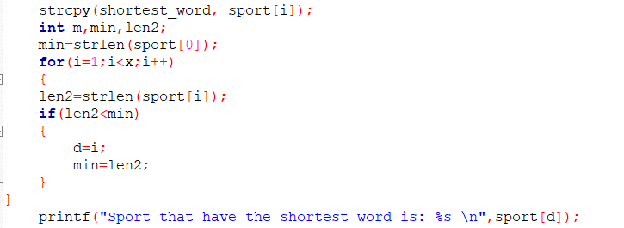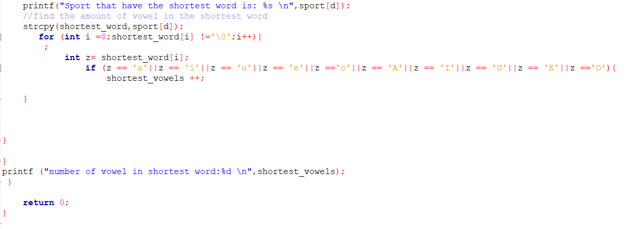

* To find the shortest word and its vowel count in the spring, we can use the same code to find We need to declare a new value and change it so that len 2 < min, which will print out the shortest value. If we keep it at len 2 > min, then it would confuse the compiler.

RESULT

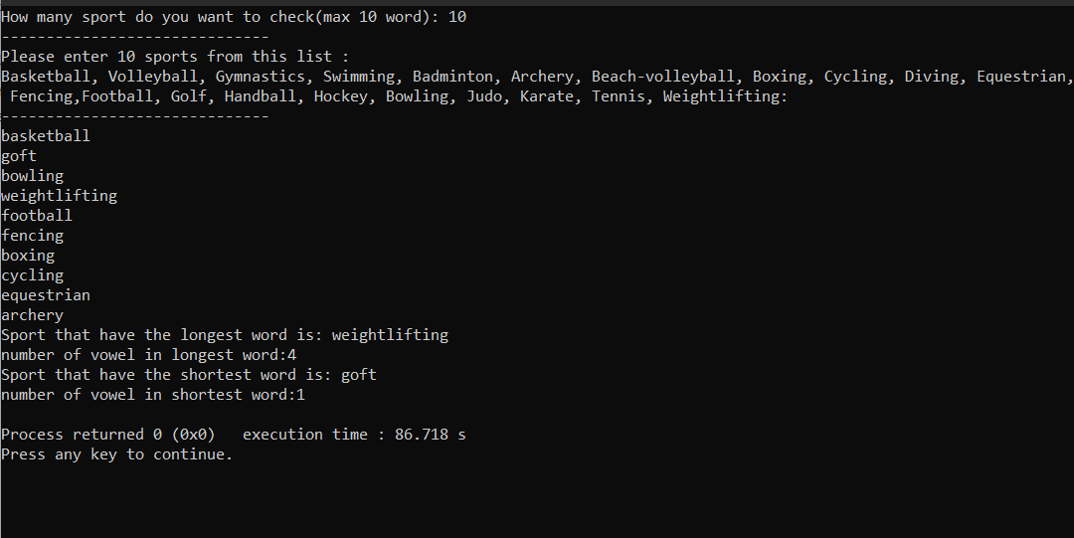

**REFERENCE**

* Aditya Singh. “Coding Ninjas Studio.” Www.codingninjas.com, 30 June 2023, [www.codingninjas.com/studio/library/c-program-to-count-the-number-of-vowels-in-a-string](http://www.codingninjas.com/studio/library/c-program-to-count-the-number-of-vowels-in-a-string) (Accessed 12 Nov. 2023)
* C program to count the number of vowels, consonants and so on (2023) Programiz. Available at: https://www.programiz.com/c-programming/examples/vowel-consonant-frequency-string (Accessed: 29 November 2023).
* Portfolio Courses (13/1/2022)Find and print the longest word in a string | C programming example .Available at: https://www.youtube.com/watch?v=vpdraEnrFnU (Accessed: 25 November 2023).
* AI, C.S. (2021) C program to find the largest/longest string, C Program to Find the Largest/Longest String. Available at: https://www.computerscienceai.com/2017/12/c-program-to-accept-n-strings-and.html#google_vignette (Accessed: 29 November 2023).
* Jain, D. (2023) Pseudocode - loops guide, Online Pseudocode Editor &amp; Compiler. Available at: https://pseudocode.deepjain.com/guides/loops/ (Accessed: 29 November 2023).
* Flow chart symbols (2022) C Programming Simple Steps. Available at: https://www.c-programming-simple-steps.com/flow-chart-symbols.html#google_vignette (Accessed: 29 November 2023).